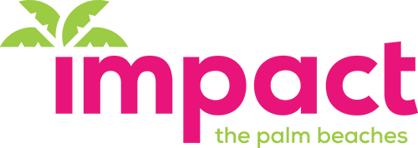
2024-2025 Grant Finalist Summary Adopt-A-Family
Impact Focus Area: Education
The Organization:
Over its 40-year history, Adopt-A-Family of the Palm Beaches has become a leading champion for lower-income families experiencing/at risk of homelessness. Through eviction prevention, emergency shelter, rapid re-housing, 112 supportive housing units, case management and ancillary referrals, Adopt-A-Family helps marginalized households achieve stability and self-sufficiency. Two-thirds of their clients are the minor children of the 1,200 families served annually.

The Project:
Adopt-A-Family will fund the reimagination and renovation of the greenspace and playscape used daily by the elementary school students who attend Project Grow, the agency’s after-school/summer program for children who have grown up with homelessness and poverty. It will also be used by children whose parents attend adult enrichment classes in the evenings and is open on weekends for specific times for supervised open play. “The Turf” as it is affectionately known, is an outdoor haven for children who have few places to run, climb and play.
The playscape, with slides, towers and climbing features is the original from when the outdoor space was developed in 2003. It has been repaired periodically but is at the end of its useful life. The scope of the work would include replacing the 2,640 square feet of underlayment and artificial turf covering and installing a new playscape with elements specifically designed to meet the needs of children on the autism spectrum or with unique learning differences.

How will this program impact Palm Beach County?
The Project Grow playground is the program’s most-used element, the source of happy, healthy, developmentally essential outdoor play. It is difficult to overstate the importance of the playground to the children of Adopt-A- Family. Program and agency leaders are unanimous in the belief that students thrive, in part, because of the sanctuary and safe haven the playground provides. Harvard University health research supports this view, indicating that outdoor play can improve children’s executive and social functioning. Adopt-A-Family programs give the children their only opportunity for daily unstructured play that includes running, climbing, soccer, basketball and other forms of exercise. It will affect many children over the course of its 20-year lifespan.

Measurable Outcomes:
90% of students earn promotion to next grade level. 90 of parents engage in academic advising services
80% of students demonstrated improved social-emotional functioning and self-regulation.

How will Impact of Palm Beaches grant be used?
$40,000 Playground resurfacing, $30,000 custom play structure, $5,000 large overhead canopy, $5,000 cone spinner and $20,000 playground equipment installation.

